Intelligent AI Agent for India’s Union Budget and Economic Insights

Author: Yash Suhas Bedagkar
Date: 2025-11-05
Executive Summary:
The India’s Union Budget & Economy AI Agent is an intelligent multi-path system built to simplify access to India’s budget and economic information. It combines Google Gemini LLM, LangChain, FAISS, and Plotly to deliver accurate, context-aware, and visually interactive answers to user queries.
The system intelligently routes queries through one of five paths Calculator, RAG, Web Search, RAG + Visualization, or Web + Visualization ensuring the most efficient and relevant response. It retrieves key insights from official budget documents, performs real-time web searches for current data, and generates interactive visualizations of economic trends.
With a user-friendly Streamlit interface, the agent provides a conversational experience that combines retrieval, reasoning, and visualization. The modular design ensures scalability and easy integration of future enhancements such as additional budget years, multilingual responses, and predictive analytics.
This project demonstrates how AI-driven document retrieval and intelligent routing can make complex fiscal data accessible and insightful for citizens, analysts, and policymakers alike.

Project Github Link:
https://github.com/yashbedagkar/EY_AI_Training/tree/main/Nov%205/Project

INDEX

Table of Contents | Page No
Problem Statement | 1
Objectives and Scope | 1
Architecture | 2
Technology Stack | 5
System Design | 5
Implementation | 7
Deployment & Running | 7
Testing and Validation | 8
Future Improvements | 8
Security, Privacy and Cost | 9
References | 9
UI | 9

- Problem Statement:
Interpreting and analyzing India’s Union Budget is often a complex and time-consuming process due to the vast amount of financial data, technical language, and fragmented information sources. Citizens, students, and analysts struggle to quickly extract key insights such as fiscal deficits, expenditure trends, and policy changes from lengthy government documents.
Moreover, existing tools lack the ability to provide interactive visualizations, real-time updates, or context-aware explanations that simplify budget and economic understanding.
The India’s Union Budget & Economy AI Agent aims to solve these challenges by building an intelligent, multi-path system that automatically determines the best way to answer user queries through document retrieval (RAG), web search, calculation, or visualization. This ensures users receive accurate, concise, and interactive responses, enabling faster and more informed understanding of India’s fiscal and economic landscape.

- Objectives:
- To develop an intelligent AI agent that answers queries related to India’s Union Budget and economy using natural language.
- To implement a multi-path routing system that dynamically selects between RAG, Web Search, Visualization, or Calculator tools.
- To design a RAG-based retrieval system for extracting insights from official Budget documents.
- To build an interactive visualization module using Plotly for clear economic data representation.
- To create a Streamlit-based chat interface for real-time, user-friendly interaction and result display.

- Scope:
The India’s Union Budget & Economy AI Agent focuses on providing an intelligent, interactive, and data-driven way to explore India’s fiscal and economic information.
- The system answers queries related to Union Budget, including fiscal deficit, expenditure, revenue, and key policy measures.
- It integrates multiple tools RAG for document-based insights, web search for real-time data, a calculator for numerical queries, and Plotly for visualization.
- The AI agent provides concise, contextual, and up-to-date responses, enabling quick understanding of economic indicators and budget trends.
- The architecture is modular and scalable, allowing future integration of more datasets, years, or external APIs (like RBI or MOSPI).
- The project emphasizes transparency, accessibility, and intelligent automation, serving as a foundation for future economic analytics and public data interpretation systems.

- Architecture:
Architecture Overview
The data architecture of the India’s Union Budget & Economy AI Agent is designed around modularity, intelligent routing, and seamless integration between data retrieval, reasoning, and visualization. It ensures efficient query handling by dynamically selecting the appropriate processing path for each user query.
1. User Input Layer
- The user interacts through a Streamlit chat interface, submitting queries in natural language (e.g., “What is the fiscal deficit for 2025–26?” or “Visualize GDP growth trends”).
- This input forms the starting point of the data flow pipeline.
2. Intelligent Routing Layer (Gemini LLM + LangChain)
- The Intelligent Router, powered by Gemini LLM, classifies the user query into one of five categories:
  - Calculator
  - RAG (Retrieval-Augmented Generation)
  - Web Search
  - RAG + Visualization
  - Web + Visualization
- LangChain orchestrates communication between the router and the respective modules.

3. Knowledge & Data Sources
- Budget Documents (RAG Data):
PDF documents of India’s Union Budget are preprocessed using FAISS for fast similarity search.
- Web Data (Dynamic Knowledge):
The system fetches real-time economic data using DuckDuckGo Search (DDGS) and summarizes it through Gemini.
- User Queries (Dynamic Input):
The system processes both structured (calculations) and unstructured (natural language) data seamlessly.
4. Processing Components
- RAG Tool: Retrieves relevant text chunks from FAISS and generates context-based responses using Gemini.
- Web Search Tool: Collects and summarizes live web data for current economic trends.
- Calculator Tool: Performs arithmetic and percentage-based calculations using regex and expression evaluation.
- Visualization Tool: Converts text-based data into structured JSON and renders interactive Plotly charts for visual representation.
5. Response Generation Layer
- The outputs from the respective tools are structured into standardized responses (text or chart).
- Gemini LLM ensures coherence, clarity, and readability of the response.
6. Frontend Display Layer
- Final responses are displayed via Streamlit, which supports both textual summaries and inline interactive Plotly charts.
- The interface maintains a conversational format with session history and clear user-agent message differentiation.
7. Data Flow Summary
User Query
↓
Intelligent Router (Gemini LLM)
↓
[Selects Path: Calculator / RAG / Web Search / Visualization]
↓
Relevant Tool Executes (FAISS, DDGS, Plotly)
↓
Response Generated (Text or Chart)
↓
Streamlit UI Display
This architecture ensures that every user query is processed intelligently and efficiently combining retrieval, reasoning, and visualization to deliver comprehensive insights on India’s fiscal and economic data.

2) Diagram:
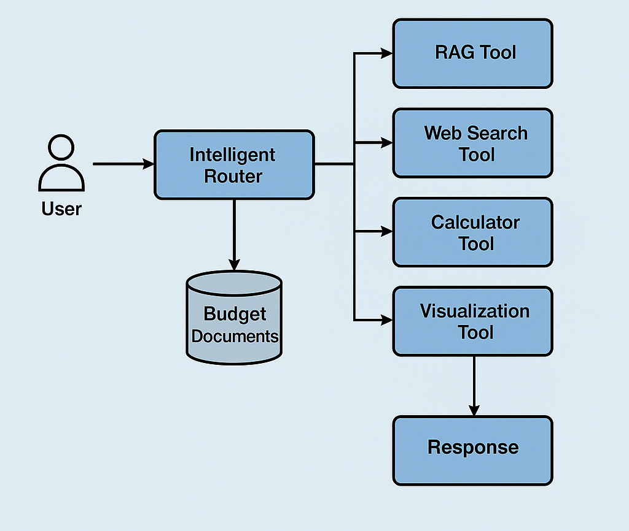
- Technology Stack:

- Programming Language: Python 3.11+
- Framework: LangChain
- LLM: Google Gemini 2.5 Flash
- Vector Store: FAISS (Facebook AI Similarity Search)
- Web Search: DuckDuckGo Search (DDGS)
- Visualization: Plotly
- Frontend Interface: Streamlit
- Environment Management: python-dotenv
- Key Libraries: langchain-google-genai, faiss-cpu, plotly, streamlit, ddgs

- System Design:

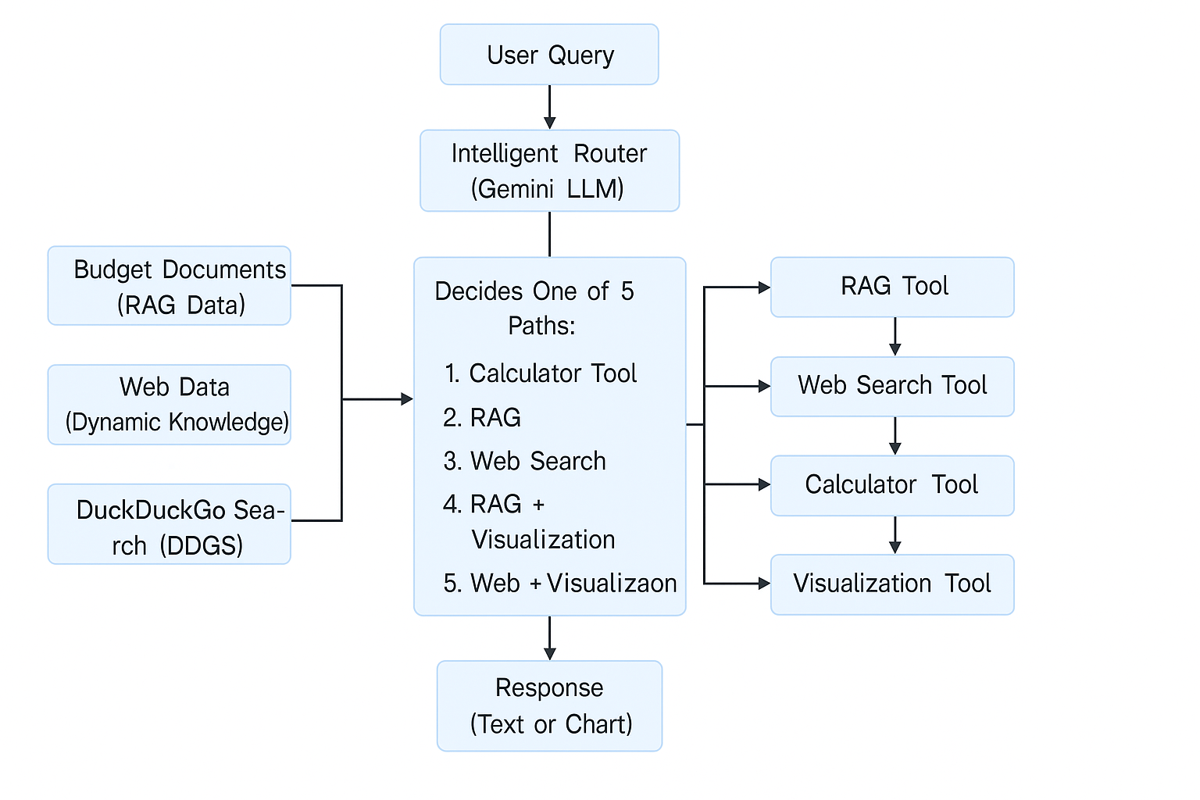

Data flow:

The data flow in the India’s Union Budget & Economy AI Agent follows a clear, multi-stage pipeline that ensures every user query is intelligently analyzed, processed, and answered through the most suitable path.
- User Query Input
The user enters a natural-language query (e.g., “What is the fiscal deficit for 2025–26?”) through the Streamlit chat interface. The system captures and sends the query to the backend for classification.
- Intelligent Routing (Gemini LLM)
The Gemini LLM acts as the intelligent router that classifies the query into one of five categories:
  - Calculator
  - RAG (Retrieval-Augmented Generation)
  - Web Search
  - RAG + Visualization
  - Web + Visualization
Based on this decision, the query is routed to the corresponding processing component.
- Data Retrieval and Processing
  - RAG Path: The system retrieves relevant text chunks from the FAISS vector store containing India’s Union Budget documents. Gemini LLM then generates a context-based answer.
  - Web Search Path: The query is sent to the DuckDuckGo Search API (DDGS), and the top 5 results are summarized using Gemini.
  - Calculator Path: If the query involves numbers or percentages (e.g., “15% of 48000”), it’s processed using regex and arithmetic evaluation.
  - Visualization Path: When a query requests comparisons or trends (e.g., “Visualize GDP growth”), the system extracts numerical data via Gemini and passes it to Plotly for chart generation.
- Response Generation
Each tool outputs structured data — either text or visualization (in JSON form). Gemini ensures that the response is concise, accurate, and easy to interpret.
- Streamlit Display
The Streamlit interface presents the response in an interactive chat format.
  - Text-based answers appear directly in the chat.
  - Visualization outputs (charts/graphs) are rendered inline using Plotly.
- Fallback Mechanism
If the RAG response lacks relevant data, the system automatically triggers a web search fallback, ensuring users always receive a complete answer.
In summary, the data flow moves from User Query → Intelligent Router → Relevant Tool → Processed Output → Streamlit Display, combining retrieval, reasoning, and visualization for a rich, intelligent user experience.

- Implementation:
1)Folder Structure:

india_budget_ai_agent/
│
├── app1.py # Streamlit UI for chat and visualization display
├── crew_agent.py # Main orchestrator and intelligent routing logic
├── chatbot.py # Builds RAG (Retrieval-Augmented Generation)
├── retriever.py # Loads FAISS retriever for document search
├── loader.py # Loads and reads Union Budget PDF documents
├── splitter.py # Splits large text into smaller, meaningful chunks
├── vector_store.py # Creates and manages FAISS vector embeddings
│
├── tools/ # Utility tools for query handling
│ ├── __calculator_tool.py # Handles arithmetic and percentage calculations
│ └── __web_search_tool.py # Performs web search & Gemini summarization
│
├── data/ # Dataset directory
│ └── budget_documents/ # Contains Union Budget PDFs
│
├── .env # Environment variables (GOOGLE_API_KEY)
├── requirements.txt # All dependencies for setup
└── README.md # Project overview and setup instructions

- Deployment & Running:
1. Prerequisites
Before running the project, ensure the following are installed and configured:
- Python 3.11+
- Google Gemini API key
- FAISS (CPU or GPU version)
- Streamlit for frontend visualization
- A stable internet connection for web search functionality

2. Environment setup:
Install dependencies
pip install -r requirements.txt
Set up environment variables
Create a .env file in the project root directory and add your Gemini API key:
GOOGLE_API_KEY=your_gemini_api_key_here
3. Running the Application
Option 1: Run in Console Mode
To test the backend logic directly:
python crew_agent.py
This will execute the intelligent router and print responses in the console for any query you enter.
Option 2: Run with Streamlit Interface
For an interactive chat experience with text and visualization:
streamlit run app1.py
This will launch the web interface in your default browser

- Testing and Validation

- Unit Testing: Verified accuracy of calculator logic, RAG retrieval, and visualization generation.
- Integration Testing: Ensured smooth communication between modules (Router, RAG, Web Search, Visualization).
- User Testing: Tested with diverse queries to validate intelligent routing and fallback mechanisms.
- Performance Check: Measured response times and ensured FAISS retrieval efficiency.

- Future Improvements

- Add support for additional budget years and multi-year comparisons.
- Integrate SQL or API-based structured economic data sources (e.g., RBI, MOSPI).
- Enable multilingual support for regional accessibility.
- Include voice-based interaction and PDF/Excel export options.
- Implement forecasting and trend analytics using ML models.

- Security, Privacy, and Cost

- Security: All API keys stored securely in .env file; no external access to local data.
- Privacy: The system does not store user queries or personal information.
- Cost Efficiency: Minimal cost due to local FAISS and free DuckDuckGo Search usage; Gemini API usage is the only variable cost.
- Data Handling: Only public financial data and government documents are processed, ensuring transparency and compliance.

- References
- LangChain Documentation
- Google Gemini API Docs
- FAISS Library (Facebook AI Research)
- Plotly Official Docs
- DuckDuckGo Search (DDGS) Library
- Streamlit Documentation

- UI :

